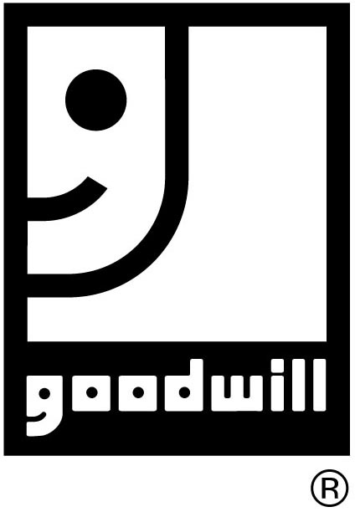
LICKING/KNOX
GOODWILL INDUSTRIES, INC.
P. O. BOX 828, NEWARK, OHIO 43058-0828
Phone: (740) 345-9861 FAX: (740) 345-3191

TO:

ATTENTION:

FROM:

DATE:

PAGES SENT (INCLUDING COVER PAGE):

SPECIAL INSTRUCTIONS:

CONFIDENTIALITY NOTICE

This Facsimile Transmission contains sensitive and confidential information and therefore is intended only for the viewing and possession of the person or persons to whom it is addressed.

The document(s) accompanying this Facsimile Transmission contain(s) confidential information belonging to the sender which is legally privileged, confidential or otherwise exempt from disclosure under applicable law. The information is intended only for the use of the individual or entity named above. If you are not the intended recipient, you are hereby notified that any disclosure, copying, distribution or the taking of any action in reliance on the contents of this Facsimile information is strictly prohibited. If you have received this Facsimile in error, please immediately notify us by telephone to arrange for return of the original documents to us.

There are no restrictions on the sharing of this information contained in this Facsimile transmission.

