Item Number: 5150288
Item: 5150288  Description: Reclining Sofa  Colors: Chocolate  Series No: 51502  Name: Lowell - Chocolate  Style: Contemporary | 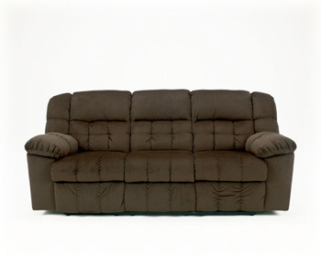

Dimensions: Inches: 85.00” W x 38.00” D x 39.00” H
Metric: 2159.00mm W x 965.20mm D x 990.60mm H
Item Features: Frames have been tested to GSA government standards. Corners are glued, blocked and stapled. Stripes and patterns are match cut. All fabrics are pre-approved for wearability and durability against AHMA standards. Cushion cores are constructed of low melt fiber wrapped over high quality foam. Features metal drop-in unitized seat box for strength and durability. All metal construction to the floor for strength and durability. The reclining mechanism features infinite positions for comfort.
Weight (lbs/kg): 210.00/95.25
Cubes (ft/m): 56.00/1.59
Cover Name: Lowell (100%)
Location:
Cleaning Code: W - Water
Contents:
polyester | (100%)

Number Of Seats: 3.00
Construction Information: Qty Description
tight back
tight seat

